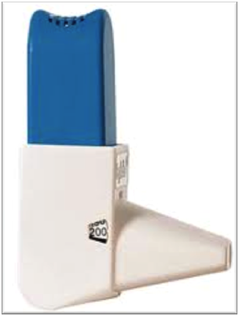
How to use your Easyhaler inhaler
Inhalers are commonly prescribed for patients with asthma and chronic obstructive pulmonary disease (COPD) as they are very effective at delivering the medication straight to the lungs where it is needed.
Using your inhalers correctly is an important part of asthma or COPD treatment. You should be shown how to use inhalers properly by a healthcare professional when they are first prescribed.
You may occasionally experience problems using your inhalers, especially if it has been a while since you were shown the correct technique. This is very common and your healthcare professional can help you improve your inhaler technique.

Why is inhaler technique important?
- It allows the correct dose of medication to reach your lungs.
- It gives you better control of your condition.
Examples of Easyhaler inhalers | Beclometasone Easyhaler
 | Budesonide Easyhaler
 | Formoterol Easyhaler
 | Salbutamol Easyhaler

Checklist for Easyhaler use
1 | Stand or sit upright when using your Easyhaler.
2 | If you use the protective cover (use is optional) open it and remove the dust cap.
3 | Hold the Easyhaler and shake 3 to 5 times.
4 | Press the top of the Easyhaler down until you hear a click, and let it click back again.
5 | Breathe out fully.
6 | Place the mouthpiece between your teeth without biting and form a good seal around it with your lips.
7 | Breathe in through your mouth as fast, forcefully and deeply as you can, for as long as you can.
8 | Hold your breath and remove the Easyhaler from your mouth.
9 | Continue to hold your breath for 10 seconds or as long as is comfortable.
10 | Breathe out slowly.
11 | If your doctor has told you to take two puffs, wait for one minute and then repeat steps 3 to 10.
12 | Replace the cap straight away to keep out dust and close the protective cover, if you are using it.

Common problems
Common mistakes that people make with Easyhaler inhalers include:
- Not standing, sitting or holding the inhaler upright.
- Not shaking the Easyhaler before using it.
- Not pressing down until you hear a click to load the dose.
- Clicking the Easyhaler by accident.
- Not inhaling strongly enough to draw the medication out of the Easyhaler and in to your lungs.
- Not holding your breath long enough after taking each puff.
- Not waiting between puffs.

Useful tips
- The use of the protective cover is optional and additional to the dust cap.
- The Easyhaler has a dose counter which shows how many doses are left. The counter turns after every fifth dose. When the numbers turn red, there are 20 doses left. When the counter reaches 0, you need to replace the Easyhaler even though you can still see the powder in the clear window on the back of the Easyhaler
- Replace the Easyhaler every six months after opening the laminate pouch.
- If you accidently click the Easyhaler, click it more than once, or breathe out in to the mouthpiece, you need to empty the powder out by tapping the mouthpiece on a table or the palm of your hand.
- If your Easyhaler contains a corticosteroid rinse your mouth out with water after your dose.
- Speak to your nurse or pharmacist if you experience problems using your Easyhaler.
- Always read the patient leaflet provided with your Easyhaler for any specific instructions.

How did I do?

For video demonstrations on how to use your inhaler visit:
https://player.vimeo.com/video/178887205

Ensure that you have your respiratory condition and inhaler technique reviewed at least annually

